Final API document:

#Post

POST      /post   json: (email, content, privacy, lon, lat) -> add a post

e.g.:

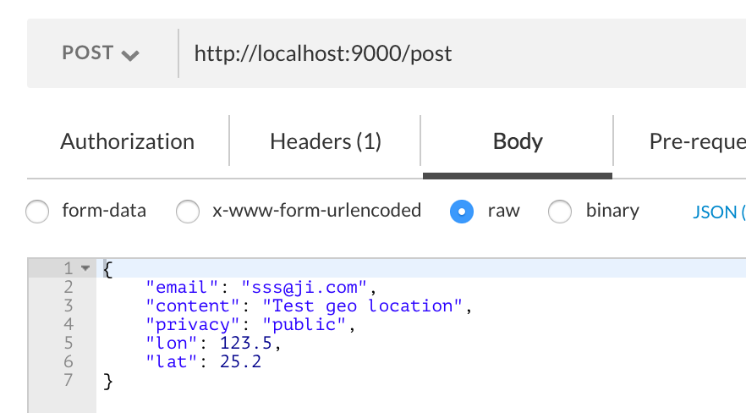

GET          /post/user/:id      user id ->  json: all posts created by a user in time desc order

e.g.: 

POST        /post/like    json: (email, postId) -> user likes a post

e.g.:

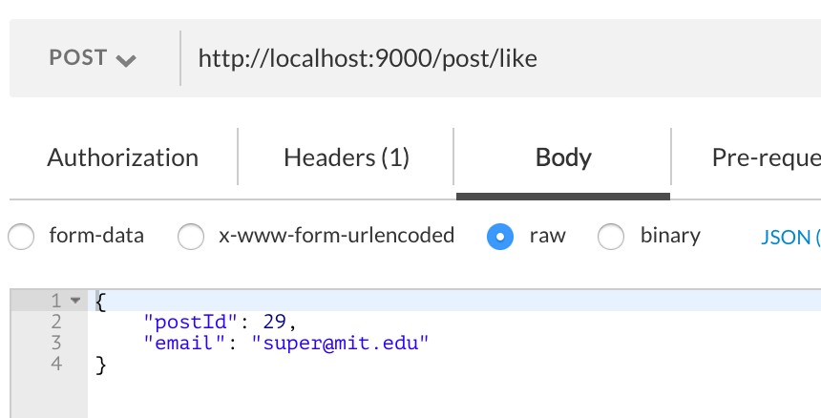

GET          /post/delete/:id          -> delete a post by id

e.g.:



POST        /post/edit              json: (postId, newContent)   -> edit a post content

e.g.:

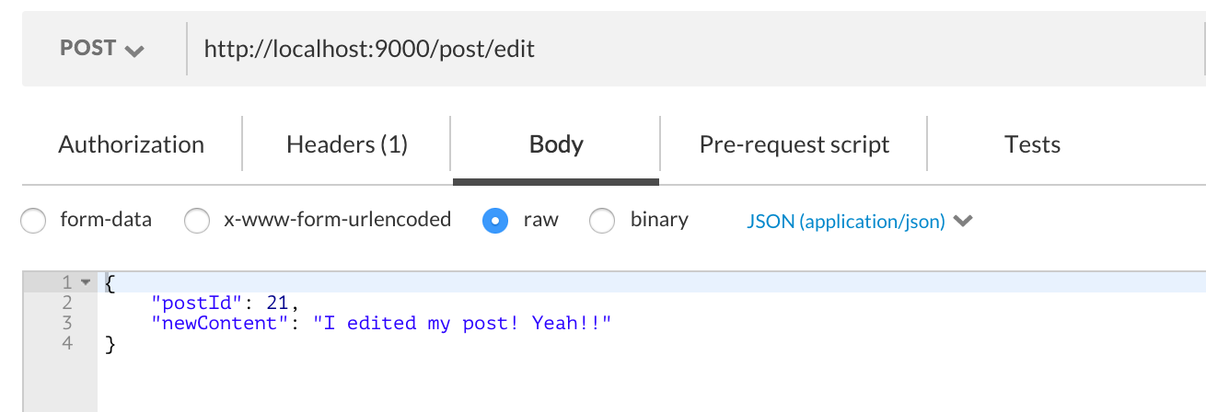

GET          /post/popular       -> return  top 10 most popular posts

e.g.:



#Share

POST       /share              json: (email, post id) -> share a post in DB

e.g.:

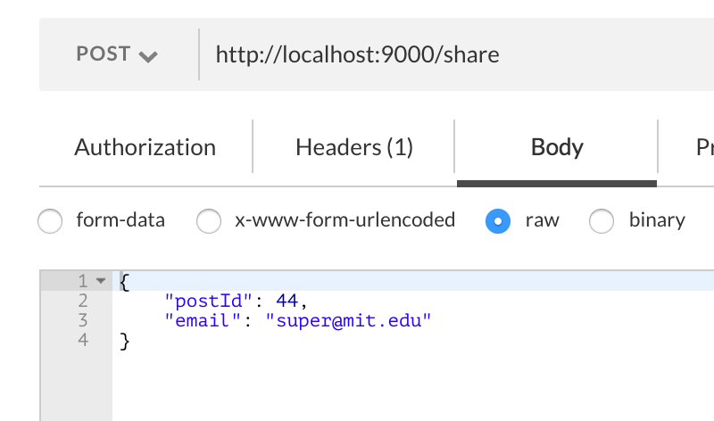

GET         /share/user/:id     user id -> json: all posts shared by a user in time desc order

e.g.:



#Follow

POST       /follow             json: (follower email, followee email) -> add a follow relationship in DB

e.g.:

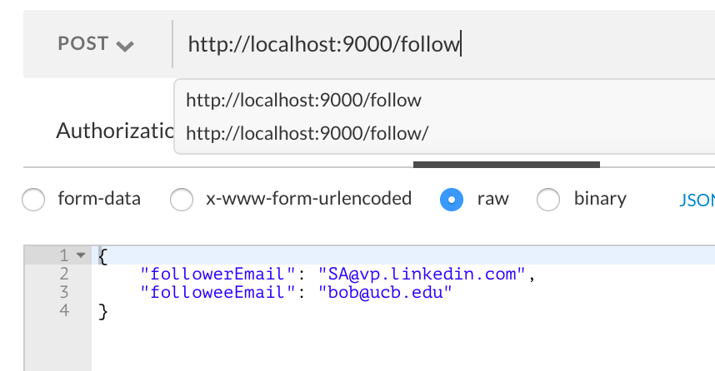

GET         /follow/user/:id      user id -> json: a list of users who are followers of a user

e.g.:



#Comment

POST   /comment json: (email, postId, comment) -> HTTP OK + json of created comment

e.g.:

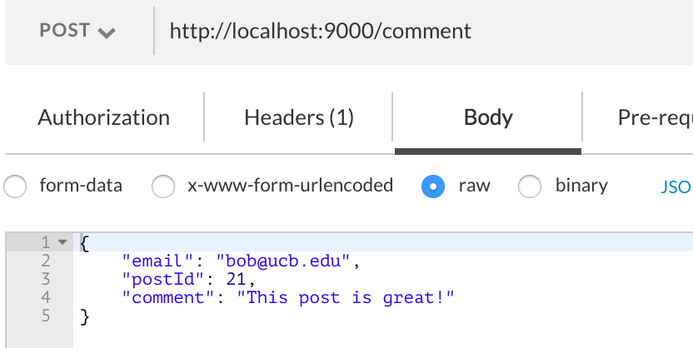

GET      /comment/post/:id               -> HTTP OK + json of all comments associated with the post

e.g.:



#Search

POST      /search/user/criteria   json: (firstName, lastName, email, affiliation, title) [email, affiliation, title] are optional   return json array of users satisfy the search criteria

e.g.:

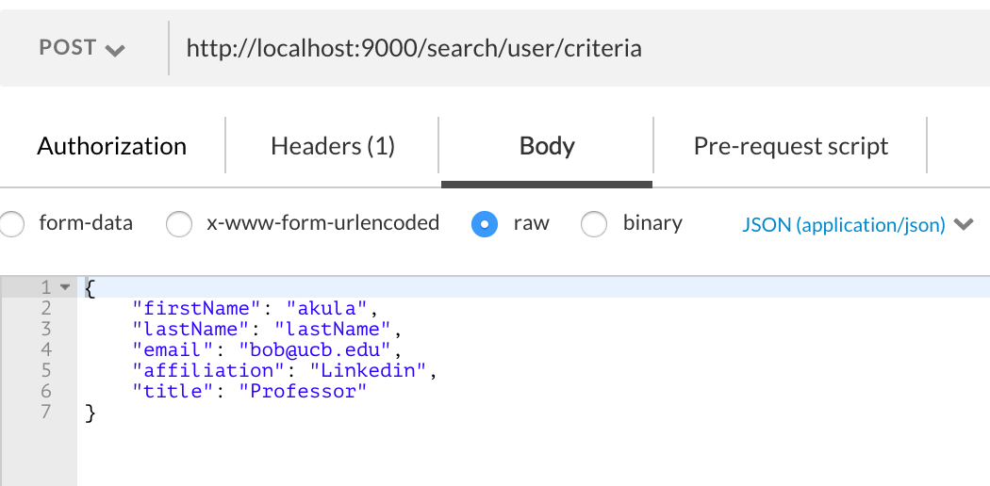

GET      /search/user/fuzzy/:partial    where partial is anything from firstName, lastName, email, affiliation, title  return json array of users (take error typing into account)

e.g.:



GET     /search/post/:keyword  where keyword is word want to search in post content return json array of posts whose content contains the keyword

e.g.:



#Autocompletion

GET     /user/autocomplete/firstname/:query  -> returns a list of users whose first name starts with the query

e.g.:



GET     /user/autocomplete/lastname/:query  ->  returns a list of users whose last name starts with the query

e.g.:



GET     /user/autocomplete/email/:query ->  returns a list of users whose email starts with the query

e.g.:

